**Interview Questions**

[**https://spoddutur.github.io/spark-notes/distribution_of_executors_cores_and_memory_for_spark_application.html**](https://spoddutur.github.io/spark-notes/distribution_of_executors_cores_and_memory_for_spark_application.html)

[**https://stackoverflow.com/questions/37871194/how-to-tune-spark-executor-number-cores-and-executor-memory**](https://stackoverflow.com/questions/37871194/how-to-tune-spark-executor-number-cores-and-executor-memory)

[**https://stackoverflow.com/questions/54577747/how-to-calculate-no-of-cores-executors-amount-of-memory-in-spark-job**](https://stackoverflow.com/questions/54577747/how-to-calculate-no-of-cores-executors-amount-of-memory-in-spark-job)

**How is Apache spark different from MapReduce**

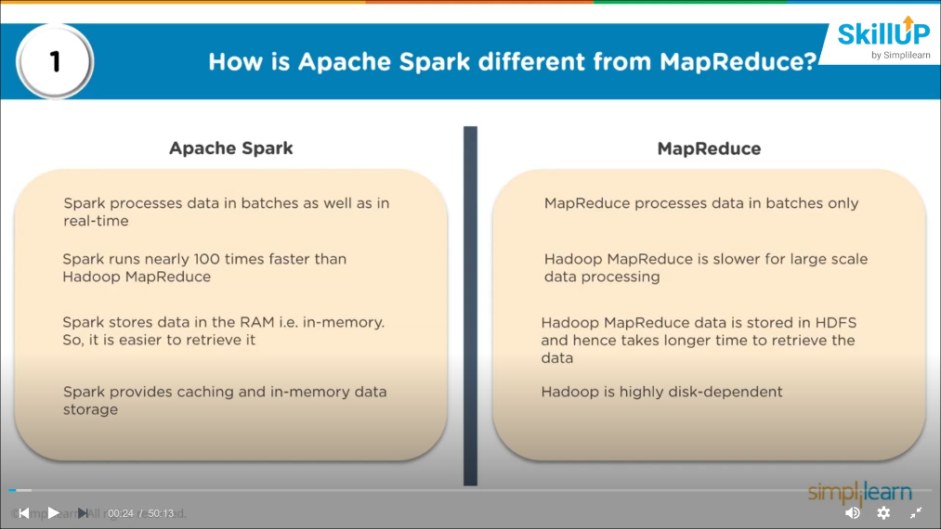

**Important components of spark ecosystem**

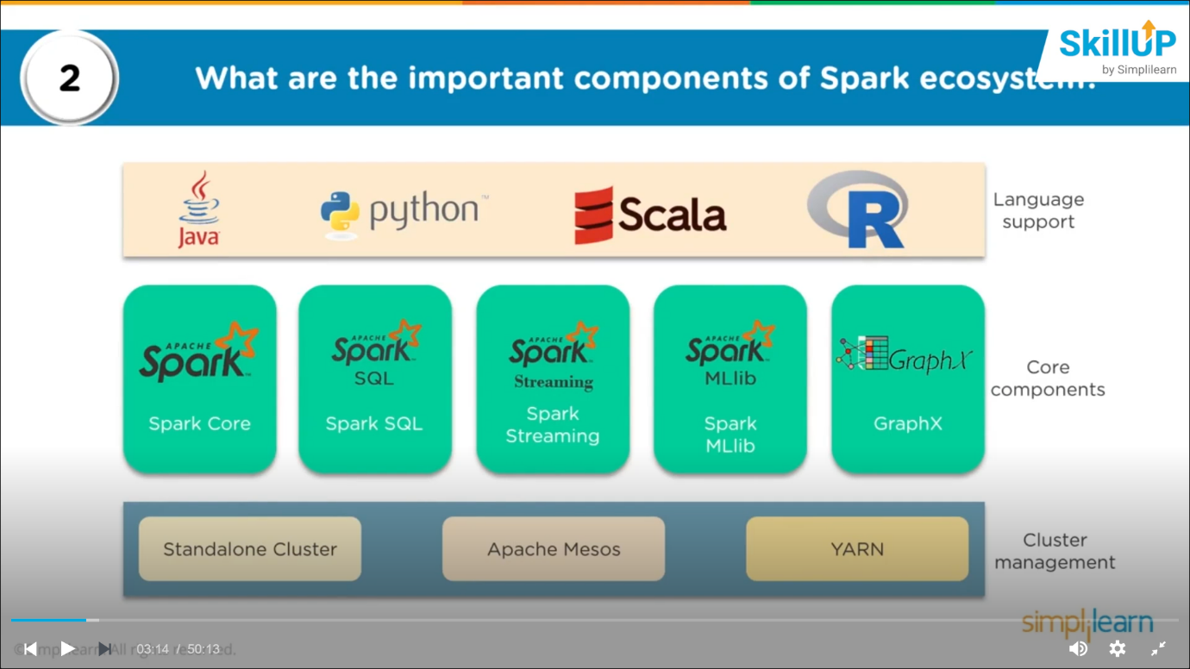

**Below 3 are important points to discuss**

* **Core components**
* **Language support**
* **Cluster management**

**Explain how spark runs the application with architecture**

* **Spark applns runs as independent process, co-ordinated by spark context in each of driver program**
* **Every appln is divided into tasks and these are distributed over the cluster.**
* **It will have spark session, spark context which are the entry point to spark functions**
* **Every spark appln has a driver 🡪 which knows the flow of execution**
* **It also has a DAG scheduler which stores the execution plan of all the task for inmemory processing**
* **Spark session / spark context interacts with the cluster/resource management (yarn)**
  + **Yarn**
    - **Resource manager (master of the cluster)**
    - **Node manager (slaves of the cluster)**

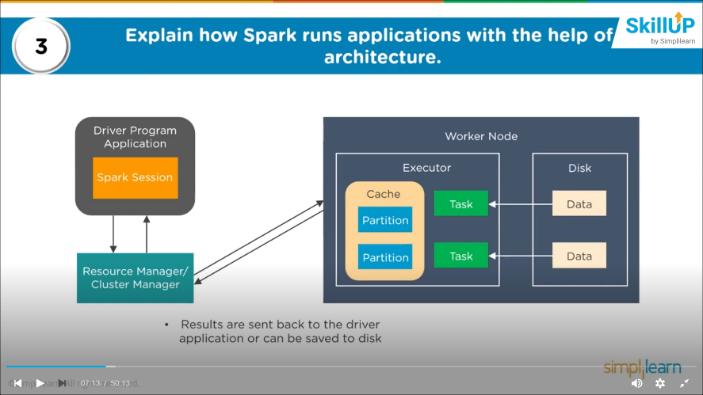

**Different cluster management in Apache Spark**

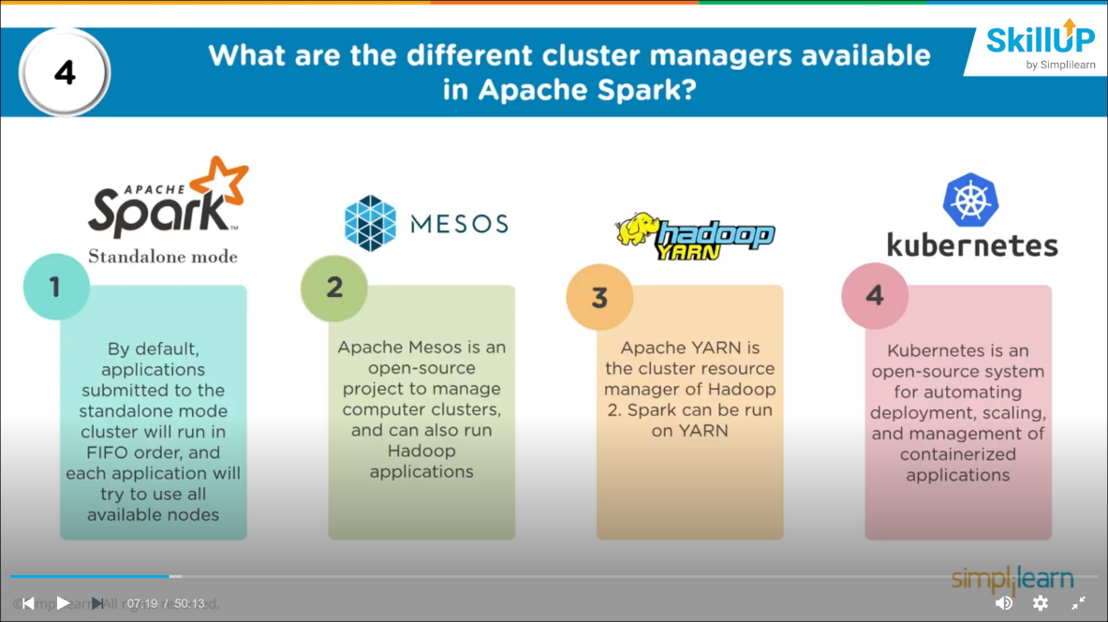

**Difference in different cluster management???**

**Lazy evaluation in spark**

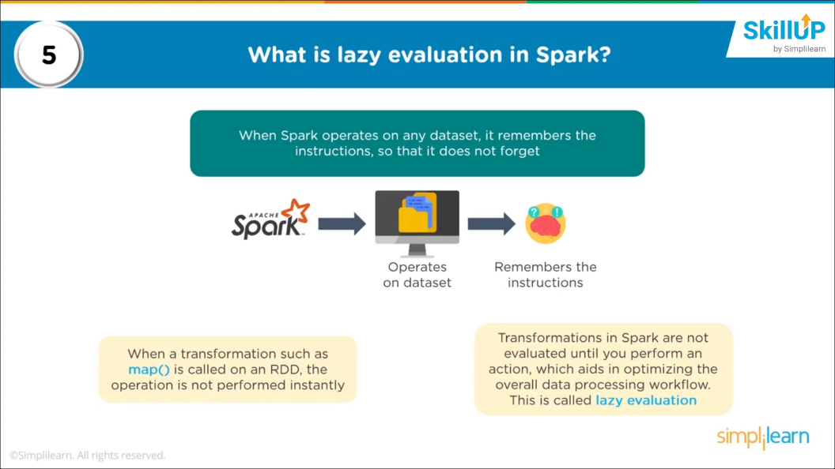

**doesn’t execute the task unless there is an action on it.**

**6. What makes spark good at low latency workloads like graph processing and machine learning??**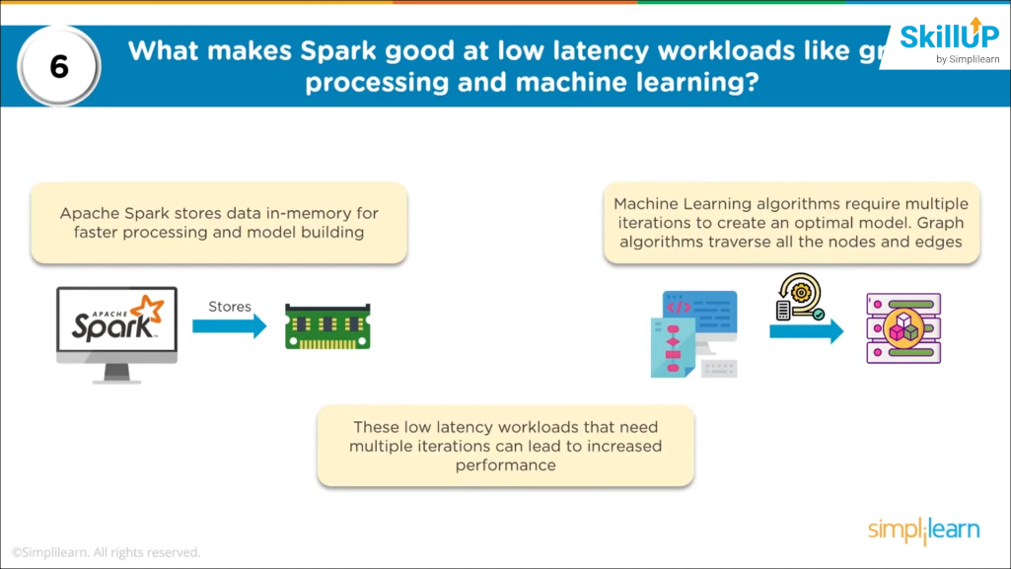

**In memory processing**

**Caching the data for further processing**

**ML requires multiple iteration to build a stable algorithm**

**Low latency workloads lead to increased performance**

**7. how can you trigger automatic clean-ups to handle accumulator metadata**

**To trigger the process we need to set the below parameter**

***Spark.cleaner.ttlx* 🡪 ttlx 🡪 time to live**

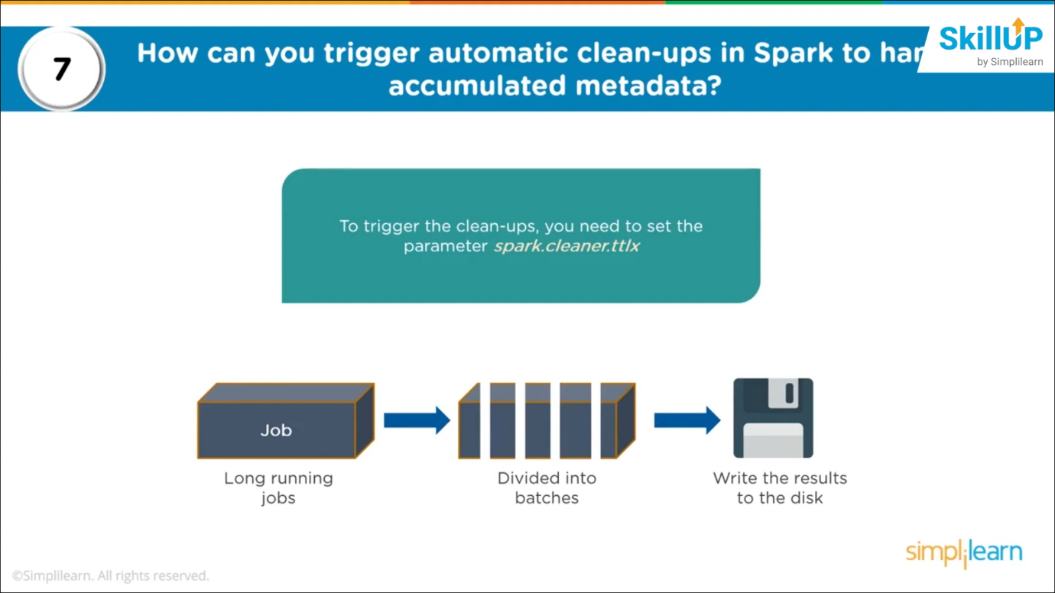

**How can you connect spark to mesos?**

* **Configure the spark driver program to mesos**
* **Put the spark binary package that can be accessed by mesos**
* **Install the spark in the same location as that of mesos**
* **Set the property for pointing the location of spark**

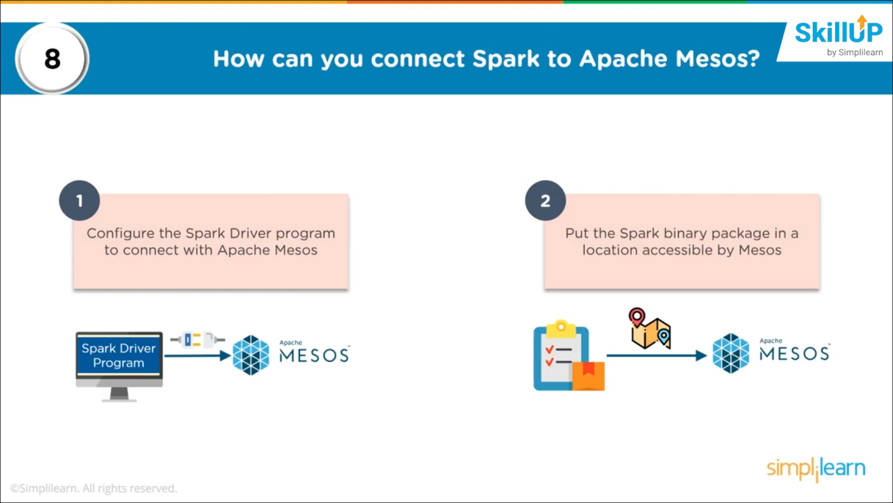

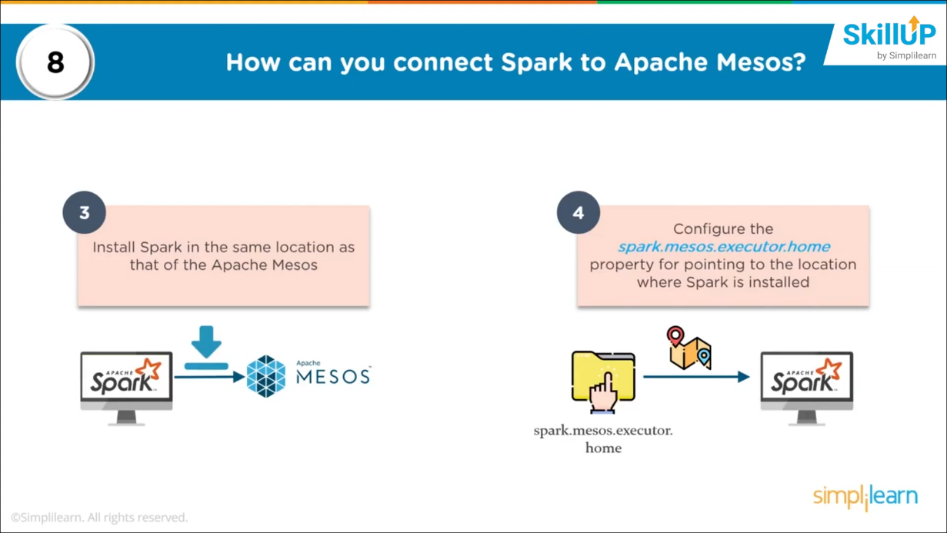

**What is parquet and its advantages?**

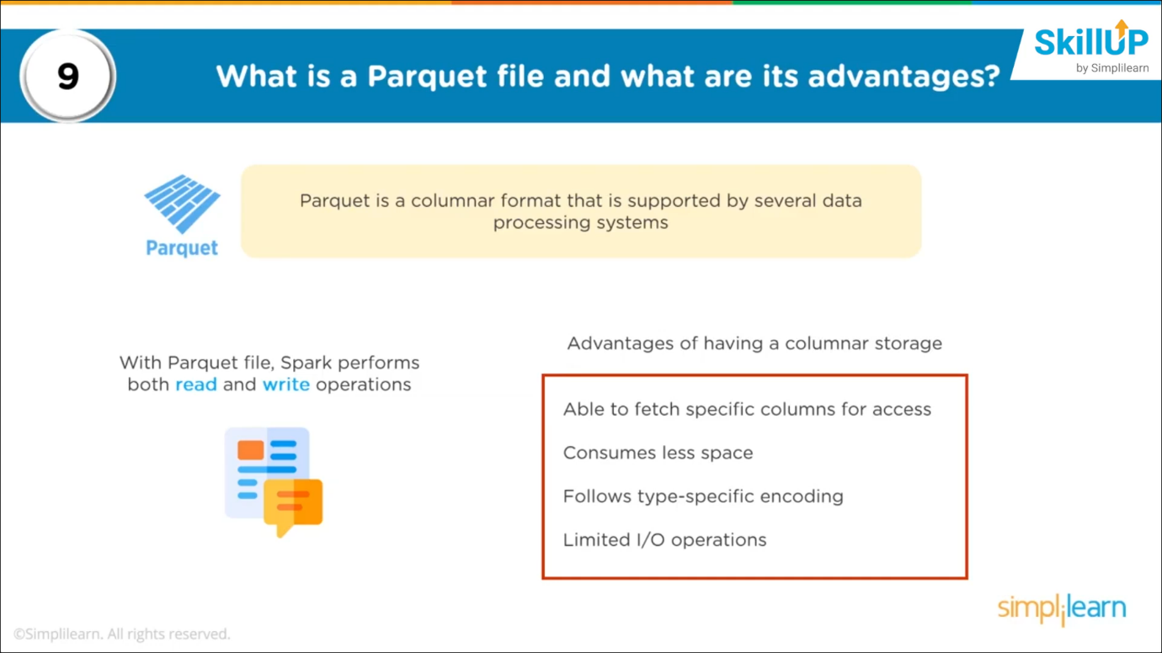

**What is shuffling in spark and when does it occur?**

**Process of re-distributing data across partitions that may lead to data movement across the executors**

**Happens where there is data processing of key value pairs and joining the datasets 🡪 data needs to be shuffled to common partitions and we can perform key based operation**

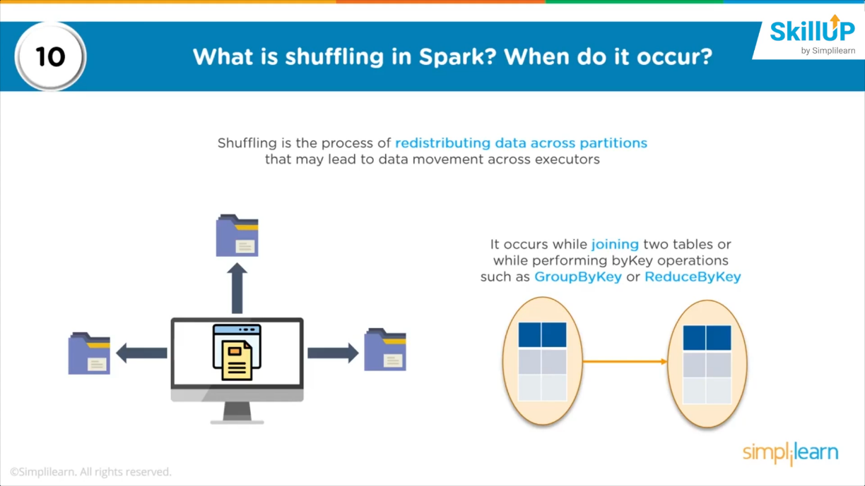

**Use of coalesce in spark??**

* + - **Used to reduce the number of partitions in DataFrame**

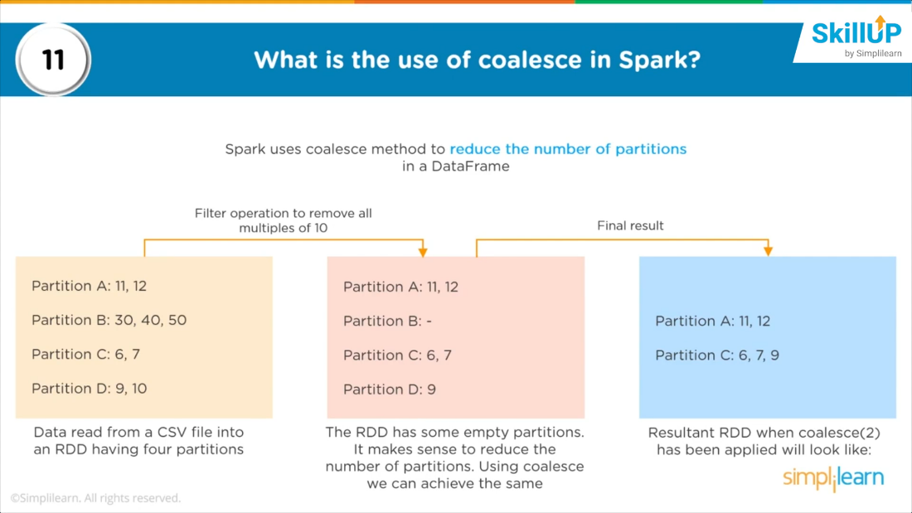

**How can you calculate the executor memory?**

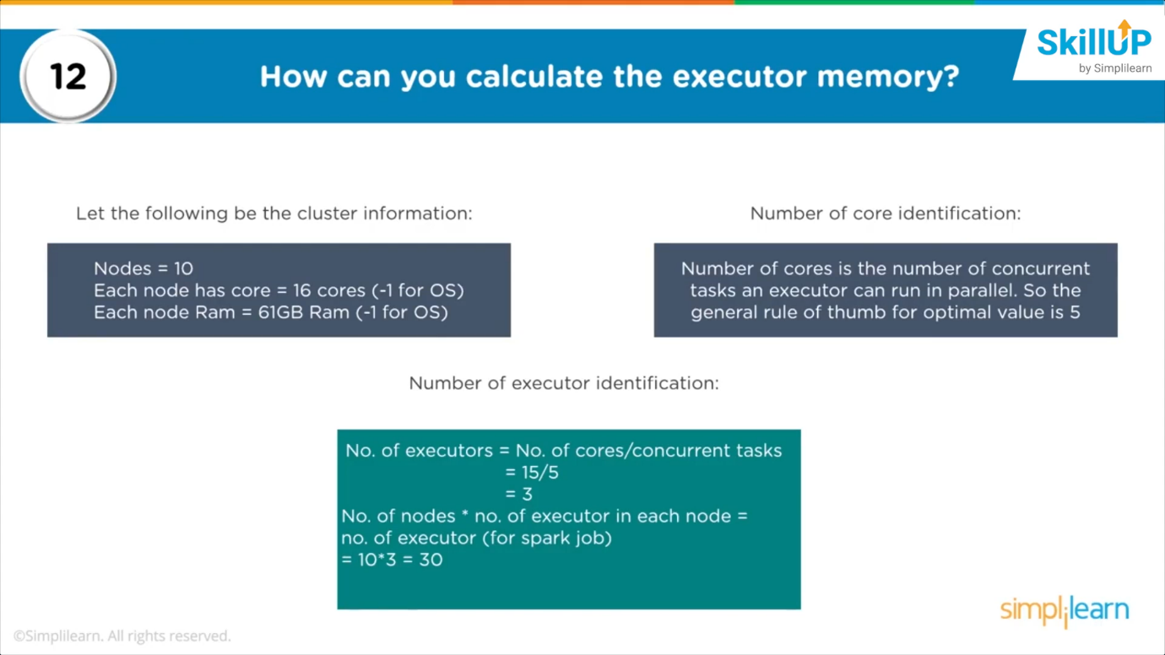

**Various functionalities supported by spark core**

* **Engine for processing parallel and distributed data**
* **Scheduling and monitoring jobs**
* **Memory management**
* **Fault recovery**
* **Task dispatching**

**Significance of RDD**

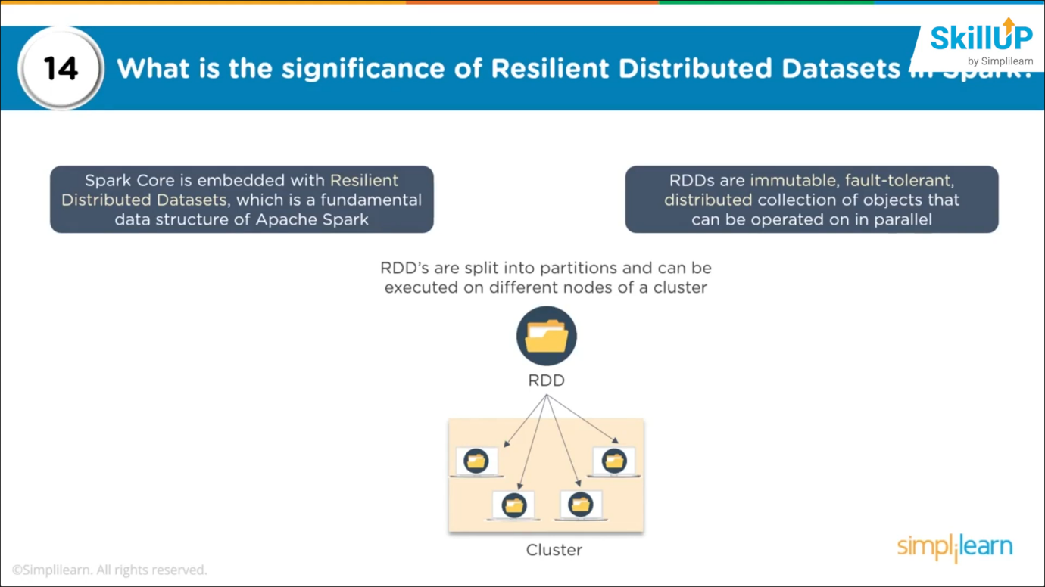

**How to convert RDD to Dataframe?**

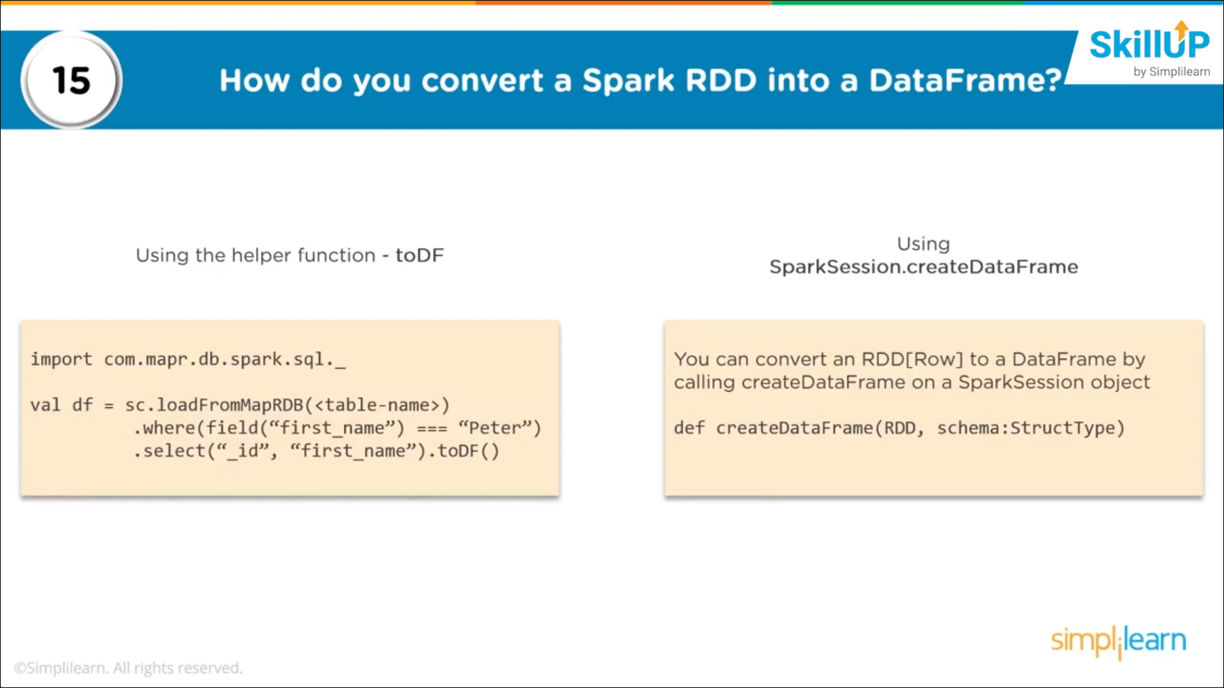

**2 types of operations supported by RDD**

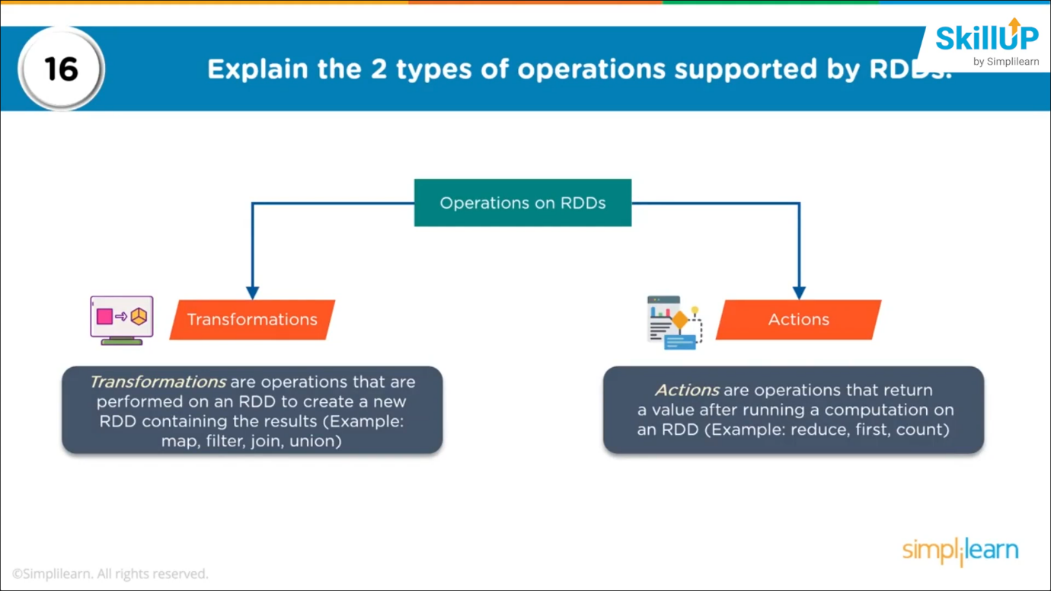

**Specify schema for Dataframe**

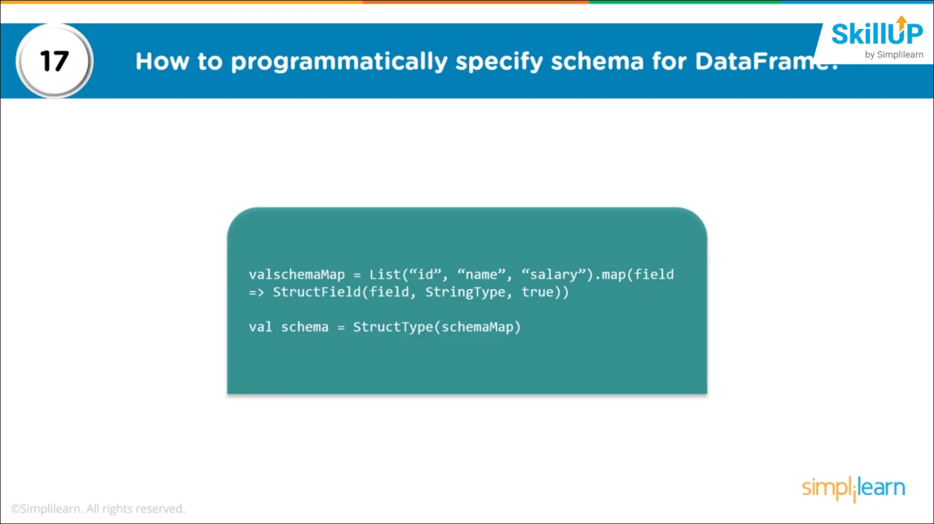

**Lineage graph**

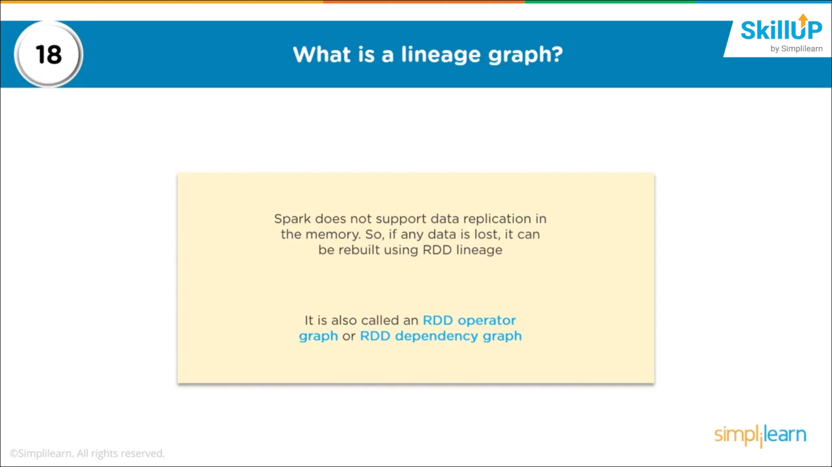

**Spark streaming**

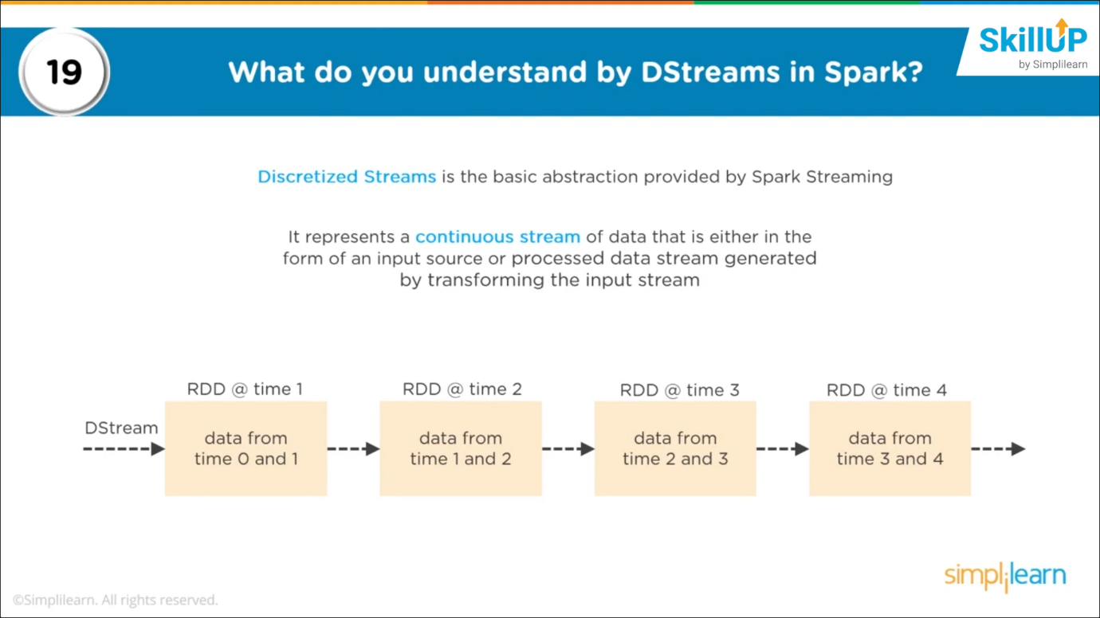

**DStreams 🡪 streaming data is broken down to smaller streams**

**Caching in spark streaming**

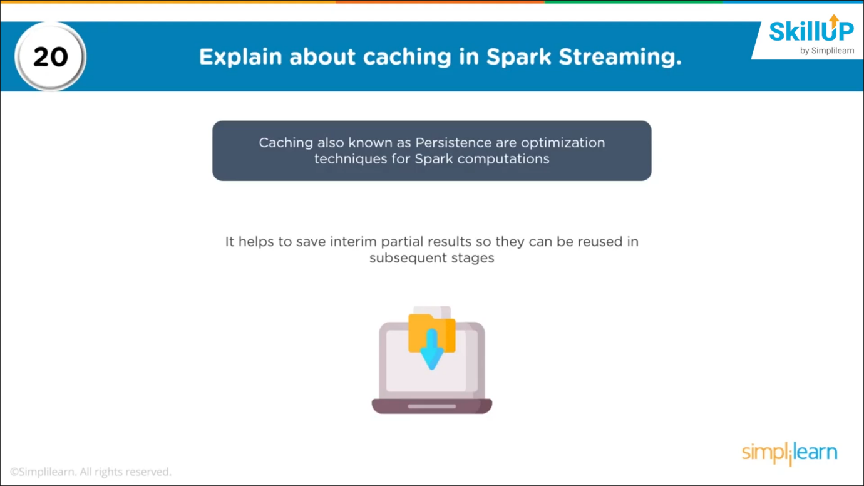

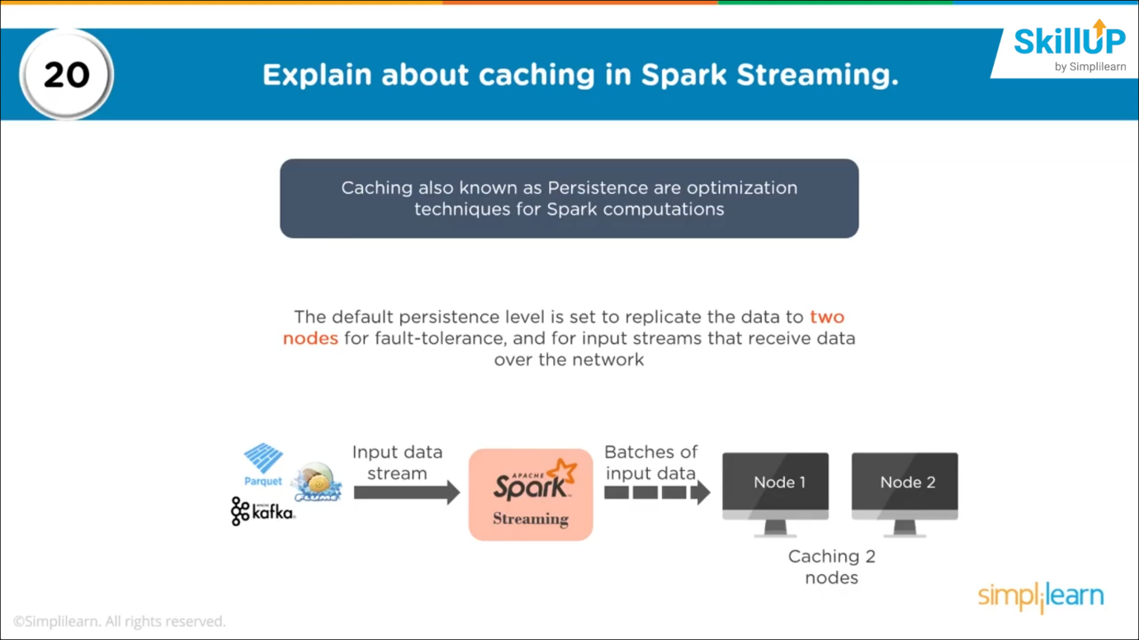

**Need of broadcast variable in spark**

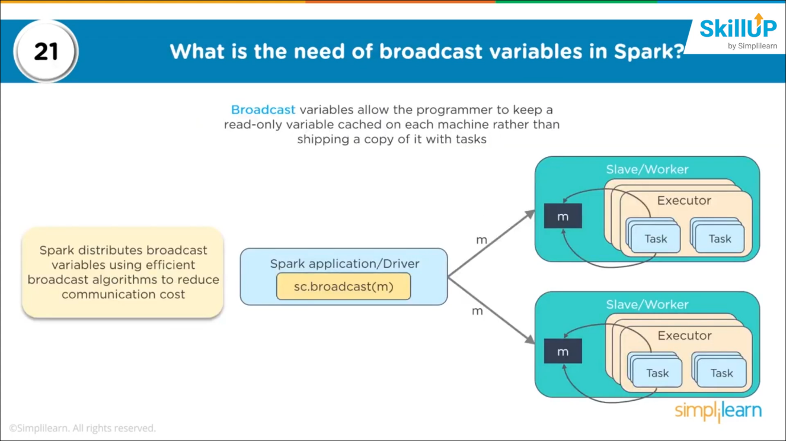

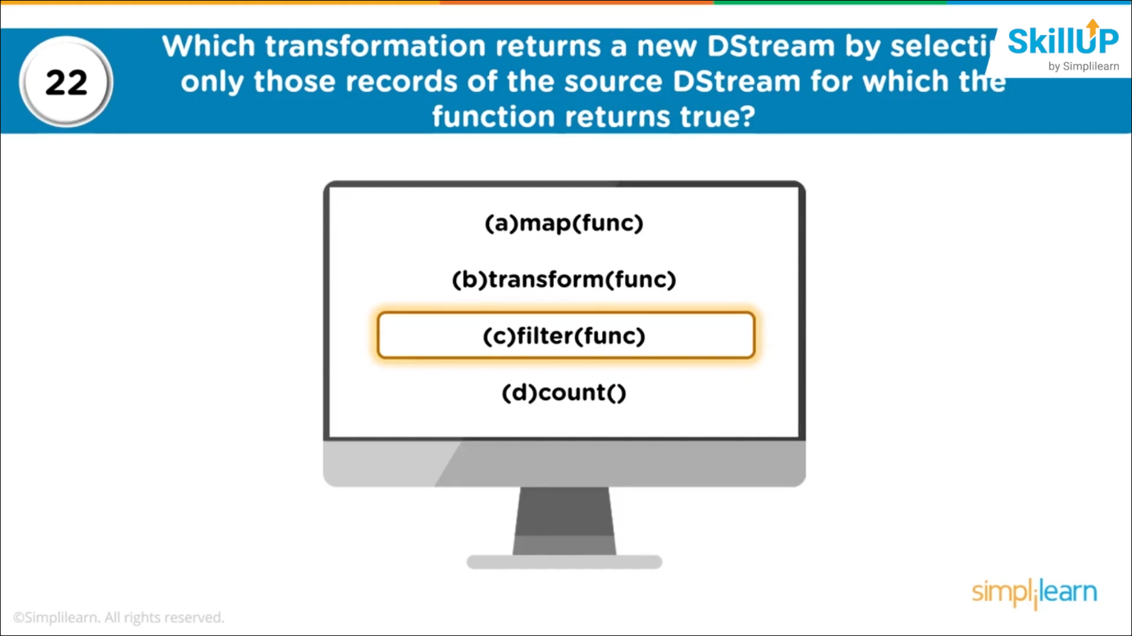

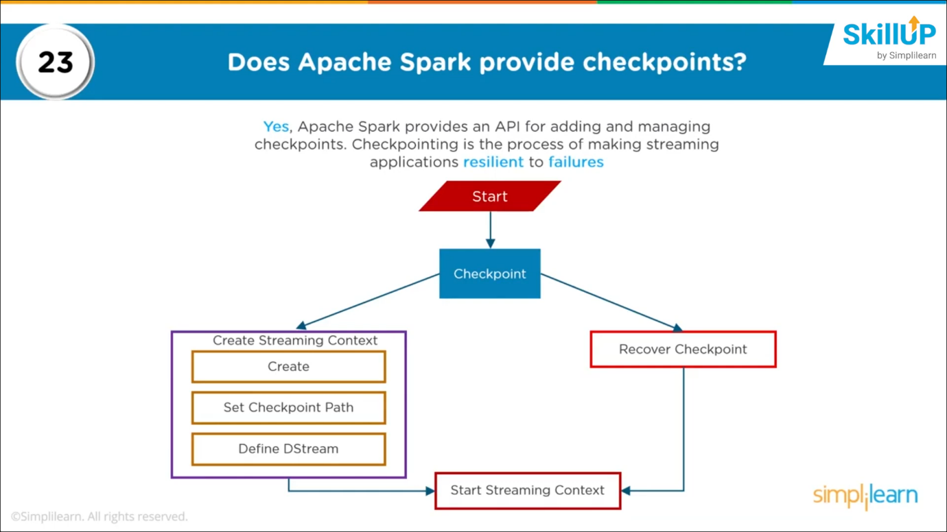

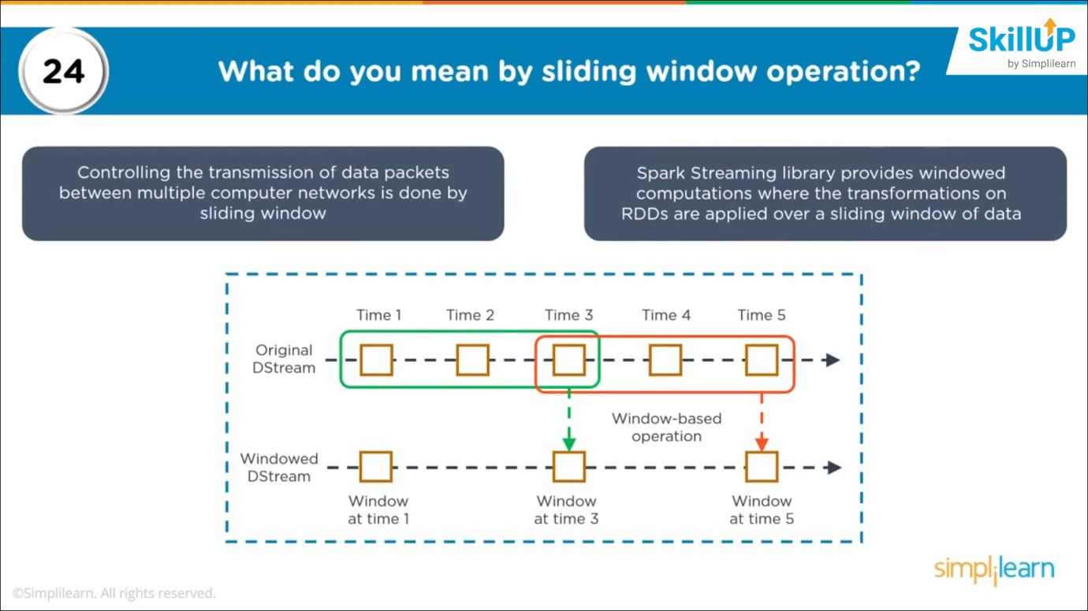

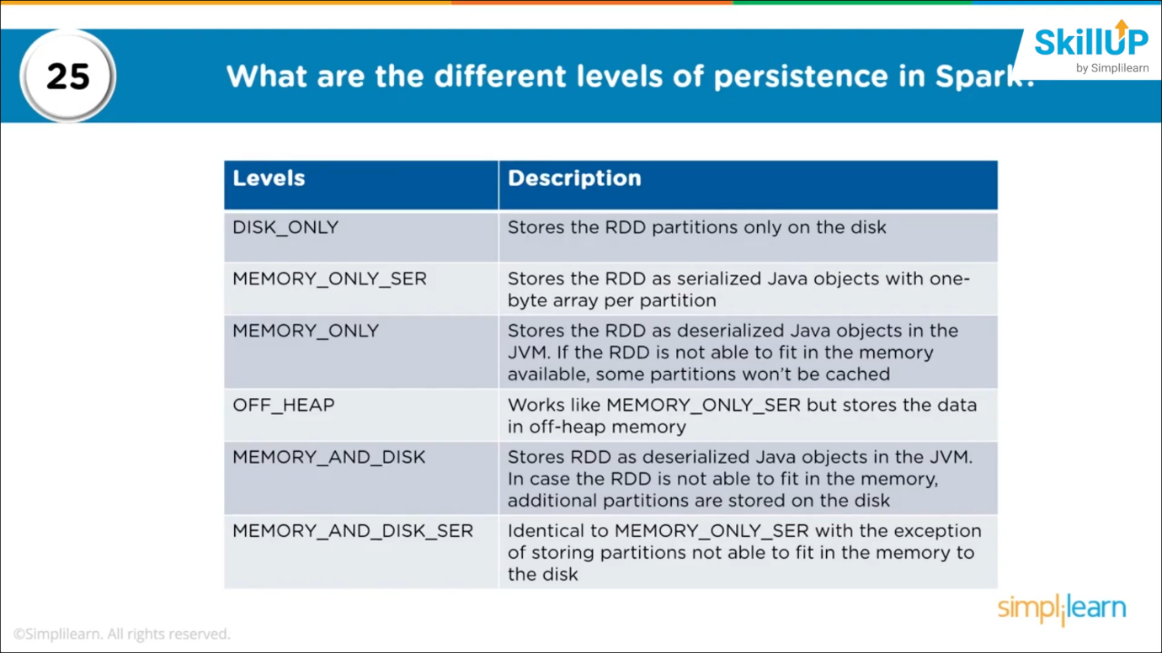

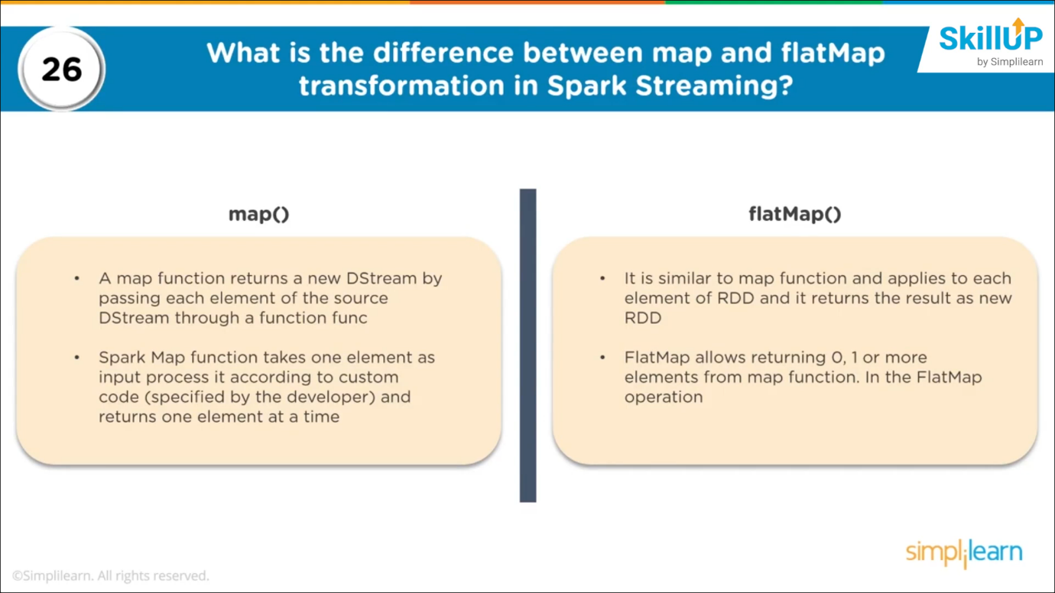

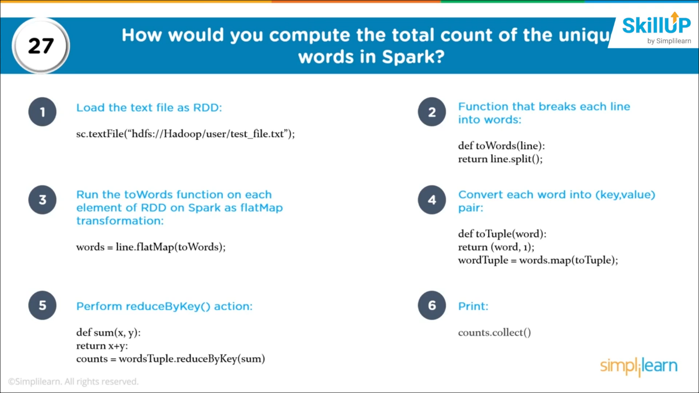

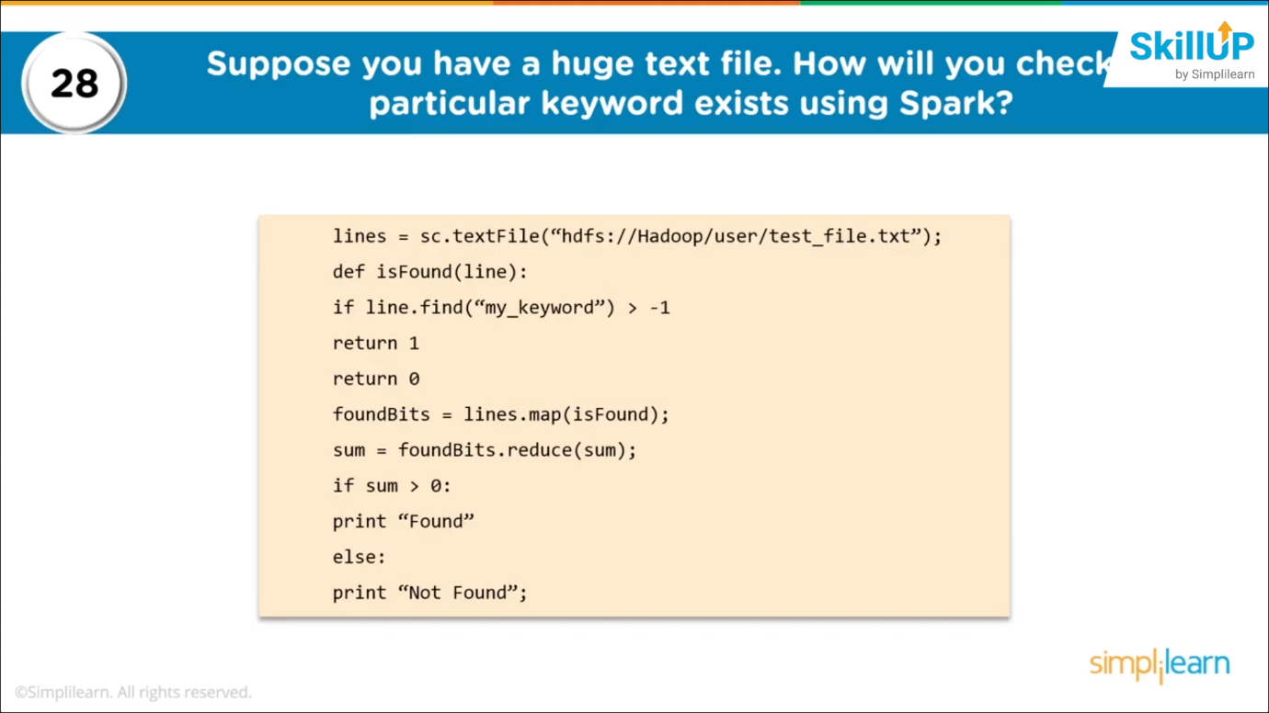

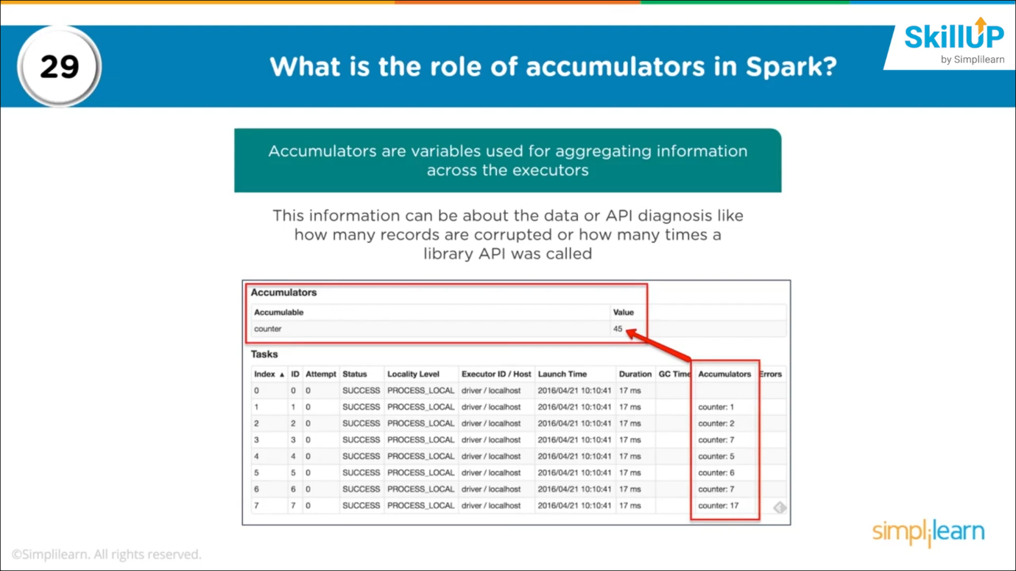

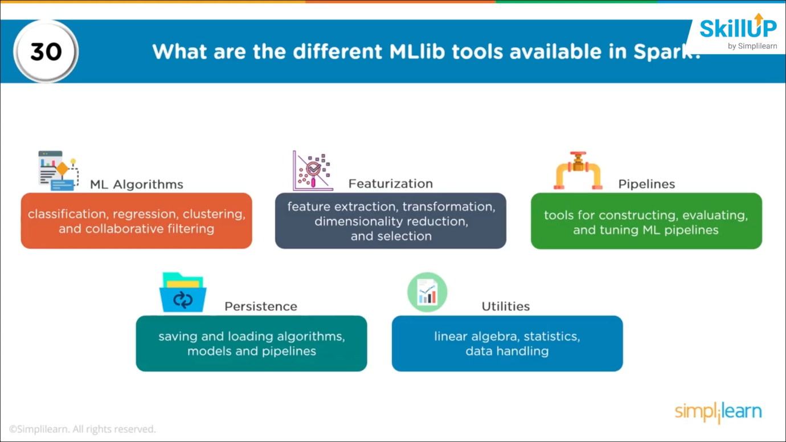

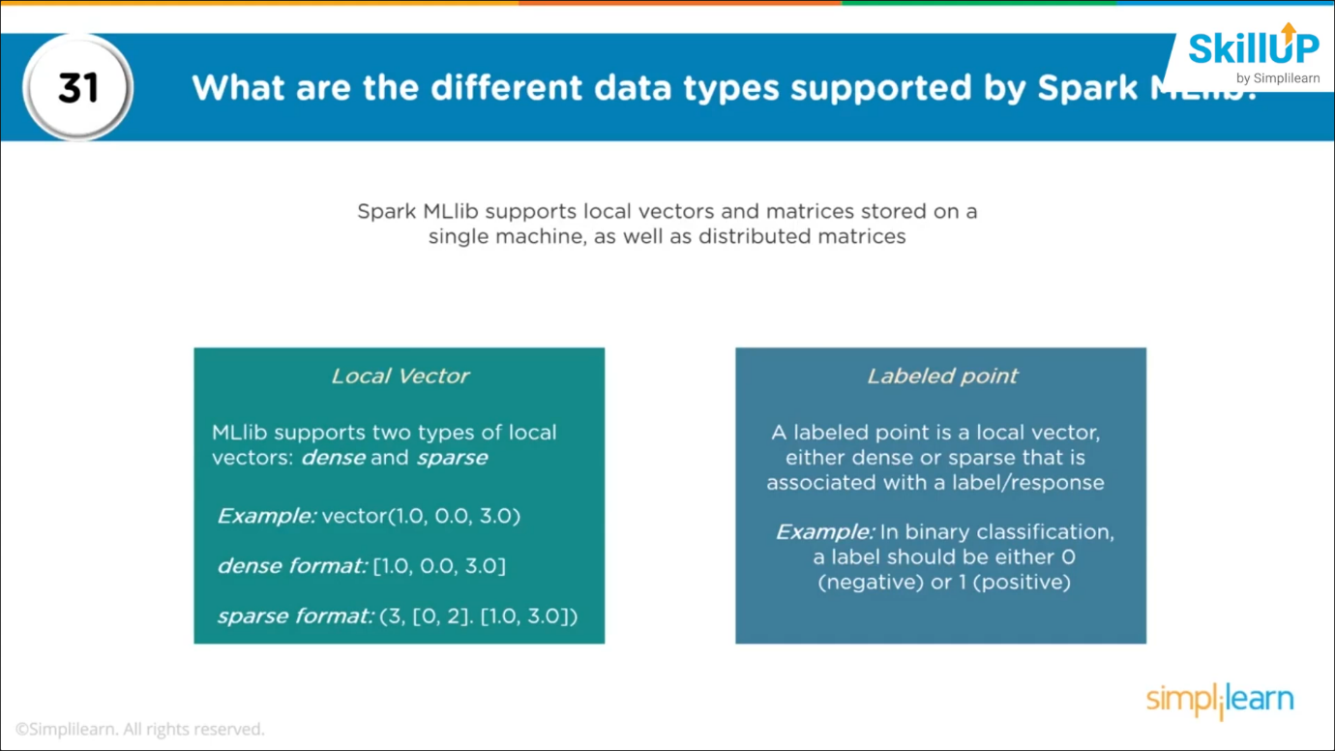

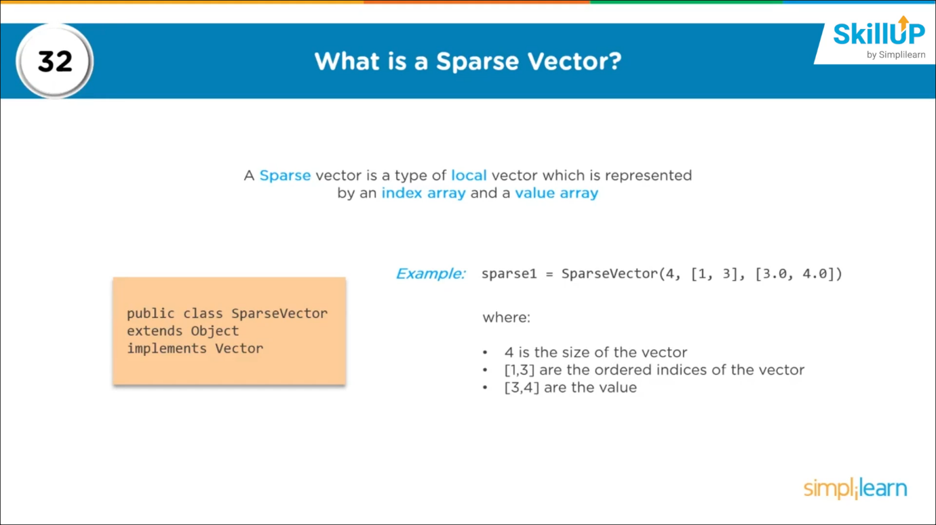

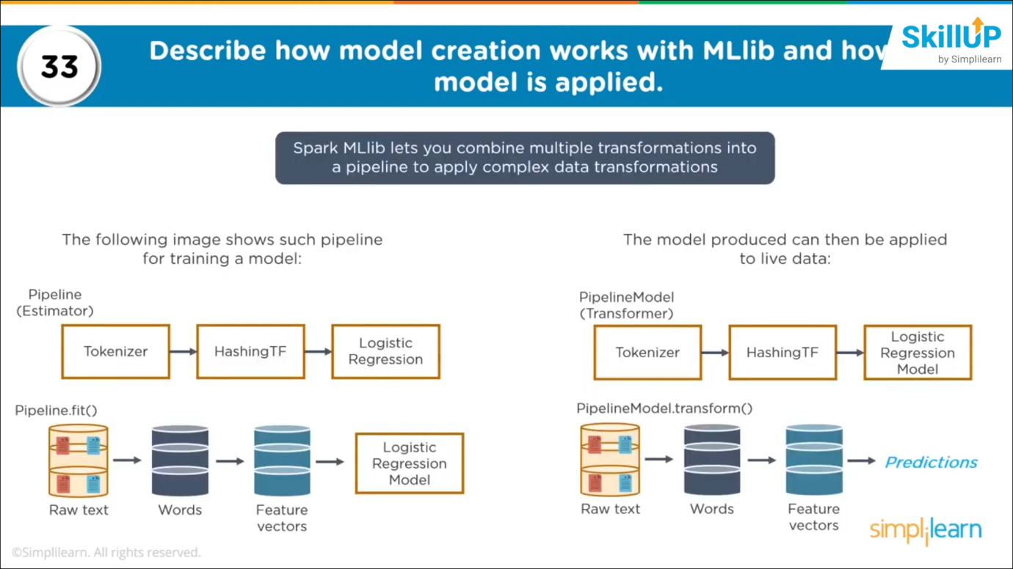

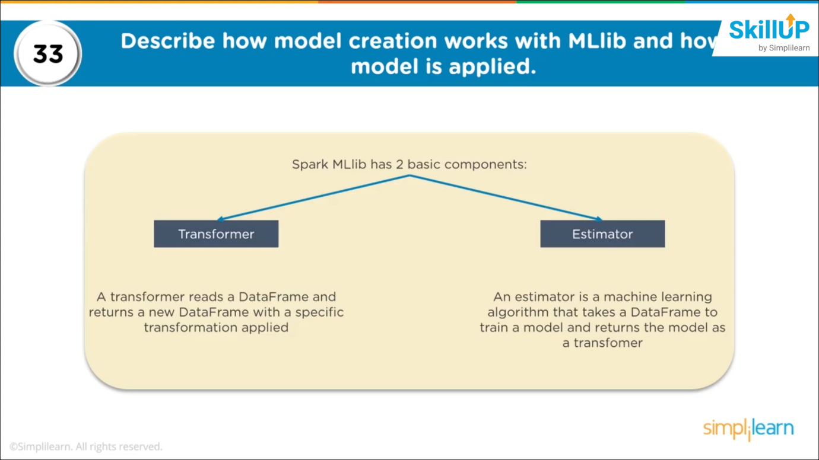

**Spark SQL:**

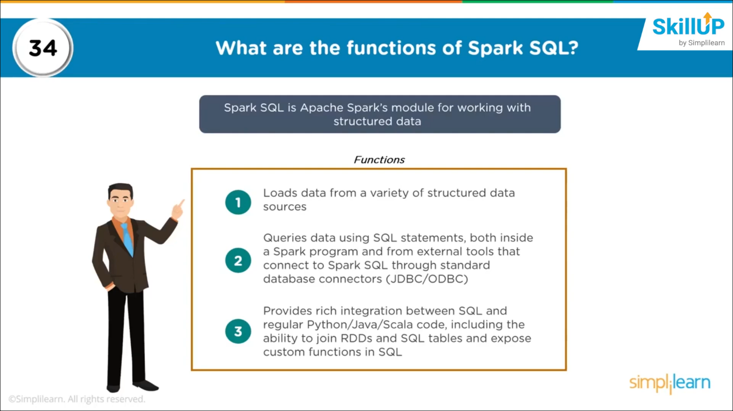

**🡪hive-site.xml 🡪 metadata 🡪 need to be placed in conf directory**

